ECSE 4810/6810 PGM Homework 3

Due 11:59 pm, October 16 via your box folder

Given the Bayesian Network below, where each node is binary with two states 1 and 0, with “1” stands for true and “0” for false.

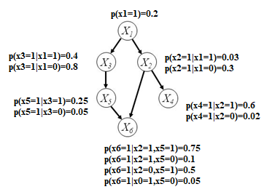

Given the model, perform a posterior probability inference of p(x1=1|x4=1 ) using

1. the clustering method [20 pts]

* Show the cluster tree, its parameters, perform belief propagation in the cluster tree, and show how to compute the probability. Hint: cluster the nodes to collapse the loop.

1. the junction tree method [30 pts] (**6000 level students only**)
   * Show how to construct a valid junction tree, estimate it’s parameters, perform belief propagation, and finally compute the probability.